Conduct and Dress Code Form

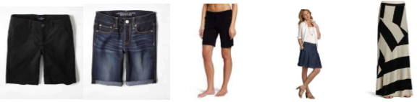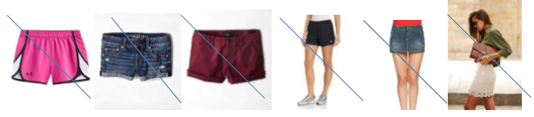

***I, the camper at Mary’s Pro-Life Boot Camp, have read the above conduct, rules and dress code and agree to comply. I realize this is non-negotiable and any violation of these rules risks immediate dismissal from the Boot Camp without refund of expenses.***

Camper Printed Name: ________________________________________

Camper Signature: ____________________________________________ Date: _______________

Parent/Guardian Signature: _____________________________________ Date: _______________

Relationship to camper: ______________________________

